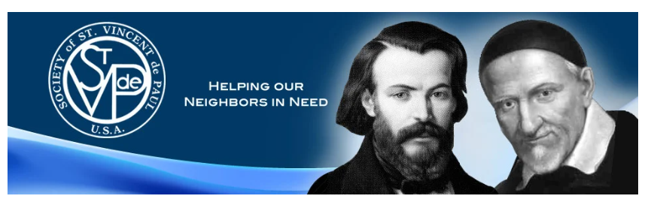

Sioux Falls District Council

October Newsletter

Dear Vincentians,

One month has passed since our last newsletter, and many changes have taken place—the start of a new school year, the arrival of fall, and transitions within our personal and family lives. A true Vincentian entrusts their needs to God and places the needs of others before their own.
As I visit and meet the many Vincentians in our Council, I am continually amazed and inspired by your dedication to our neighbors in need, even amidst your own personal challenges. This shared spirit of faith and service unites us all.
Change touches every aspect of our lives. Whether it’s starting a new job, adjusting to a school closing, watching our children grow, or supporting our parents, spouses, or loved ones through illness—change can bring both blessings and hardships. It can stretch us beyond our comfort zones, yet it also provides an opportunity to grow in the theological virtues of faith, hope, and love.
In a world that is constantly changing, we can find peace and stability in God our Father, who never changes:
“There is only one true God, eternal, infinite (immensus), and unchangeable, incomprehensible, almighty, and ineffable—the Father and the Son and the Holy Spirit.” (CCC 202)
When life feels heavy and uncertain, let us lean on God’s strength and not our own:
“Trust in the LORD with all your heart, on your own intelligence do not rely; in all your ways be mindful of Him, and He will make straight your paths.” (Proverbs 3:5–6)
St. Vincent de Paul understood this truth when he said, “If the world takes something from us on the one hand, God will give us something on the other.” (Vincent de Paul, VII:424) Living with this faith deepens our connection with God and with our Neighbors in Need.
Last month, we joyfully celebrated several feast days central to our Vincentian family—our founder, Blessed Frédéric Ozanam (Sept. 9), our patron, St. Vincent de Paul (Sept. 27), and the canonization of a fellow Vincentian, St. Pier Giorgio Frassati. Many of us gathered in prayer, Mass, and ceremonies of recommitment and rededication. These moments draw us closer to the Lord and to one another as we navigate life’s changes and grow in holiness.
As Scripture reminds us, we are the Body of Christ; when one member suffers, all suffer together (1 Corinthians 12:26–27; Romans 12:4–5; Ephesians 4:15–16).
St. Vincent de Paul, pray for us!
— Susan Anderson

FORMATION
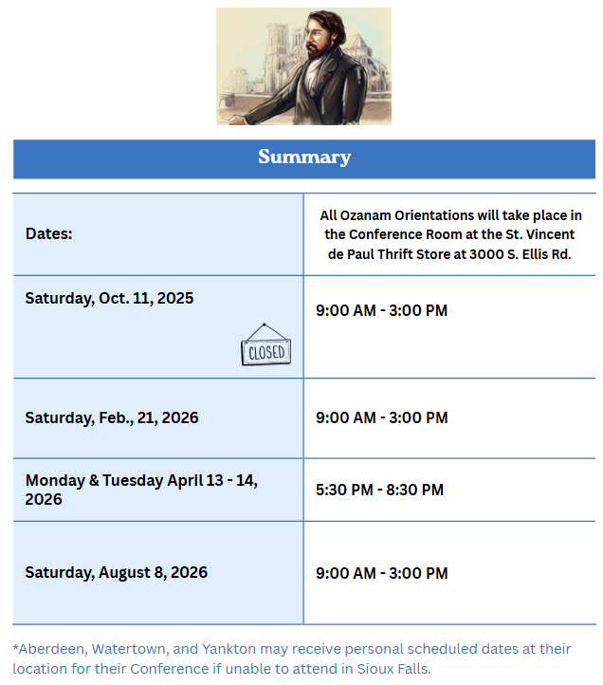
Ozanam Training- RSVP Link
_________________________________________
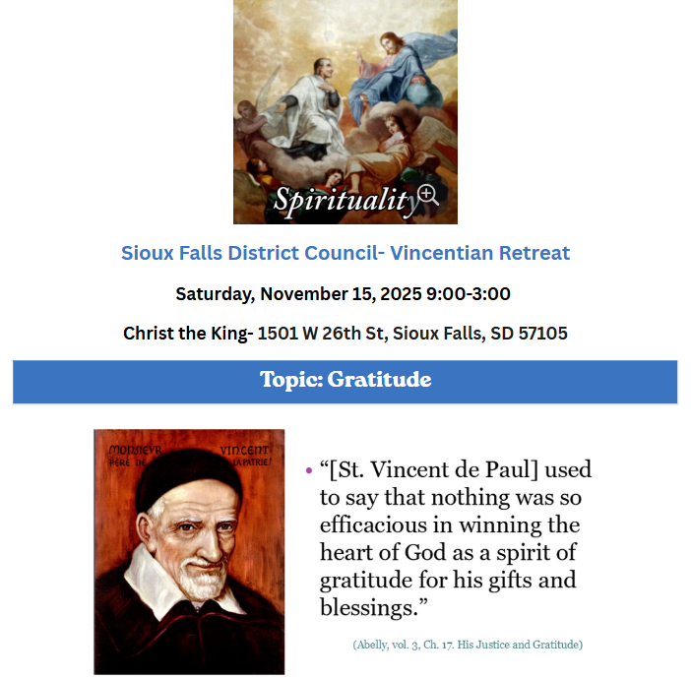
RSVP for Retreat- RSVP (Topic: Gratitude)
There will be time in the retreat schedule for opportunities to meet with other Vincentians in our Council for fellowship and discussions to learn, to grow, and to collabrate.
_________________________________________
Congratulations to Tom and Trudy from the St. Lambert Conference for completing the Ozanam Orientation!
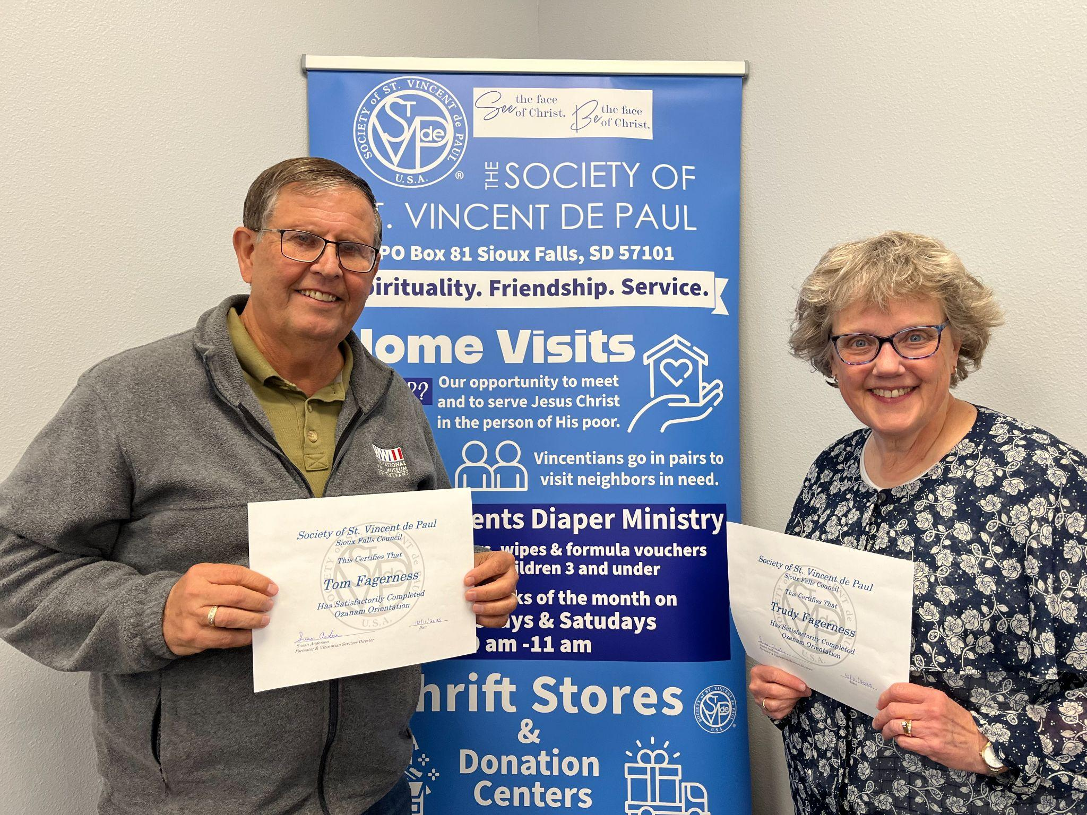
_________________________________________
SERVWARE- is an essential requirement for our Home Visits. Thanks to the large number of Vincentians who were able to attend last week's ServWare workshop with Dorothy.
Stay tuned for more ServWare workshops in the upcoming months.
_________________________________________
Annual Reporting For Conferences
Does your Conference need help with Annual Reports?
Dorothy recommends Conference officers and Vincentians to check out this webinar: RSVP
Date & Time: Oct 22, 2025 07:00 PM (Central) Description: It’s Annual Reporting time! This webinar offers a guided tour to completing your Annual Report online, with an opportunity for you to ask questions of the experts, including members of the Leadership Formation Subcommittee, and our National Director of Member Services, Pam Hudson Johnson.

HIM
- Vincentian volunteer sign up slots open! WE NEED YOUR HELP FILLING IN OPEN TIMESLOTS!
Ways you can sign up: 1. HIM Signup Genius
2. Email Dorothy executivedirector@svdpsd.org
or Deb debfsiouxfallsSVdP@gmail.com
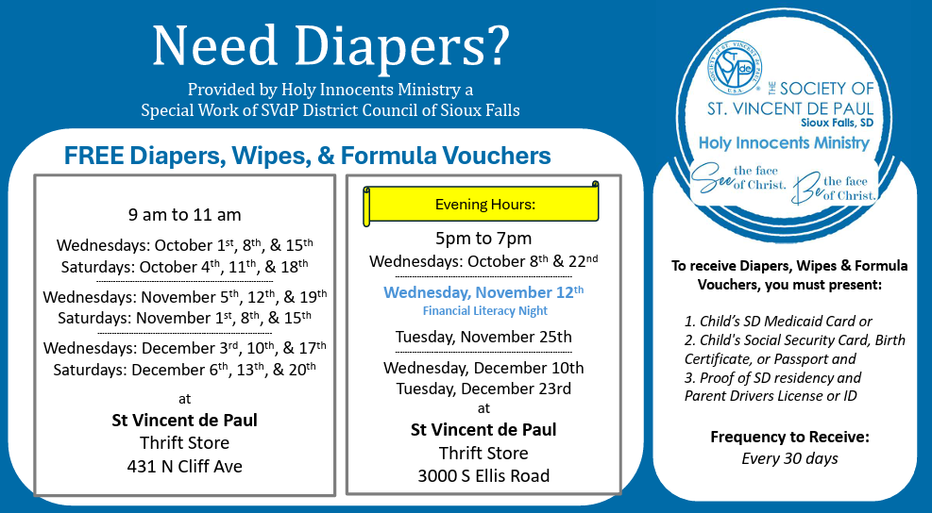

DISTRICT COUNCIL
Next Meeting: Tuesday, Oct.28th, 6:30 @ SVdP Ellis Store in the Conference Room. All Vincentians are invited to attend.
___________________________________________________________
“Vincentian Formation is the initial and ongoing process of growing and developing in the tradition, charism, and spirituality of the Society of St. Vincent de Paul. Vincentian formation means being shaped through the Holy Spirit, for and by our Vincentian work, into useful vessels God needs for the poor” (https://members.ssvpusa.org/formation).

Whether you have been a Vincentian for three years or ten and plus years, continued Formation and learning is essential!
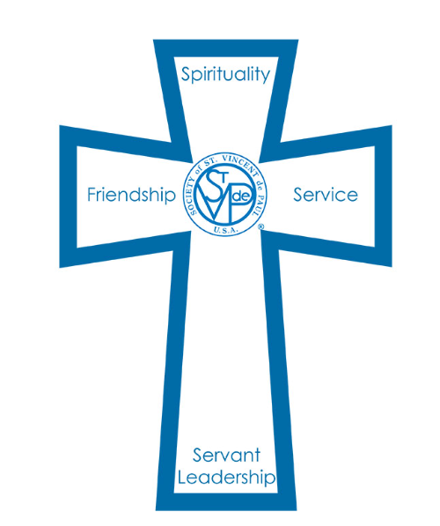
Coming Soon… Susan will offer 1 hour review sessions- offered in person and virtually:

Session: Understanding Poverty
- This session is taken from the Ozanam Orientation and materials from the Vincentian Pathway Toolbox.
- When? Winter-TBA

Session: Home Visits and Beyond the Home Visits
- This session is taken from the Ozanam Orientation and materials from the Vincentian Pathway Toolbox
- When? Spring- TBA

Home Visits
- Our Conferences often refer to the 211 Helpline to our neighbors in need. Check it out! https://www.helplinecenter.org/ Try to find where The Society of St. Vincent de Paul is posted.
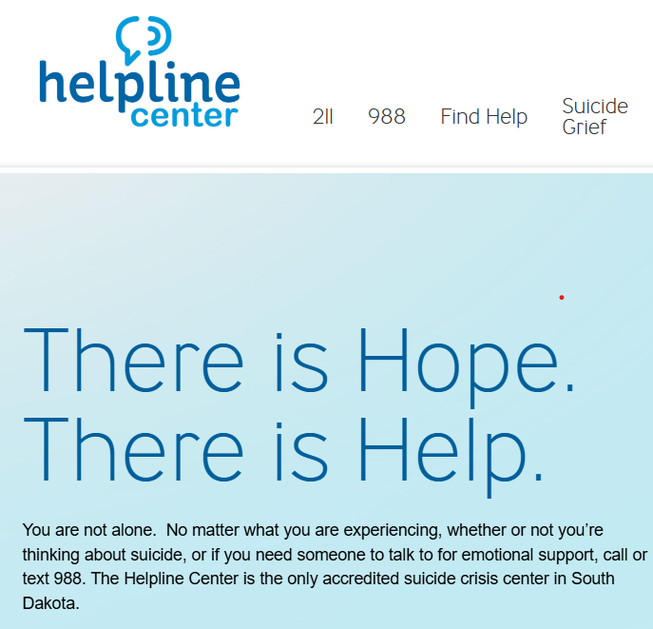
_________________________________________
- Update: The Sioux Falls Conference Presidents have a new SDvP brochure, along with 211 flyers, for Home Visits. FYI- the new brochure was recently edited to remove the blue colored background to a white background for more clarity. This was a mistake on my part. Vincentians can still use the same brochures and change them out with the edited ones. More brochures will be handed out at the District Council meeting.
- Aberdeen, Watertown, and Yankton Conference may contact Susan Anderson for brochure/flyers for their Conference.

- Vincentians can also download the brochure and other materials from our website under the tab “Members- Vincentian Services.” https://svdpsd.com/other-resources
Checkout our SVdP Website! https://svdpsd.com/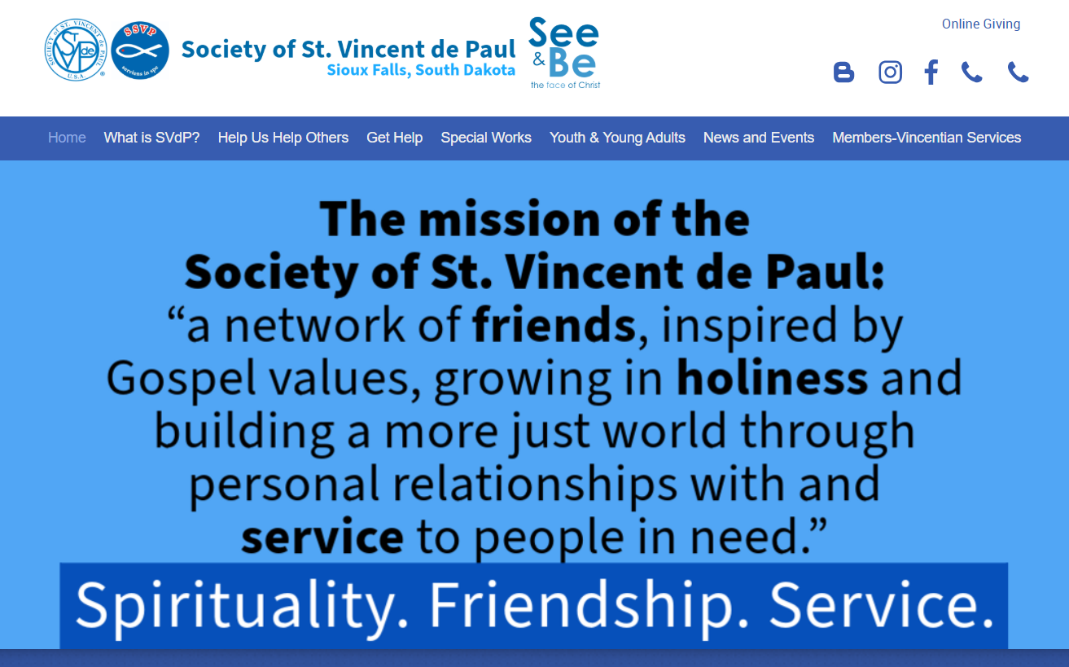
_______________________________________________
- Attention Vincentians! Are you in need of a new Home Visit Binder? Maybe yours is lost, broken, or just outdated…Open to anyone Vincentian who wants one. Complete the Google Form- or email
Google Form for Binder
Susan- vincentianservices@svdpsd.org
Some binders will be ready by the November retreat.
Binders will include the following items:
*Personalize Conference title cover
*Section Tabs with binder pouch
*Case Forms
*Release Forms
*Home Visit Guidelines
*Home Visit Prayers, Meditations, and Reflections
*Our SVdP Home Visit Brochure
*Prayer magnets to give to our Neighbors in Need
*Some Outreach Resources along with 211 info
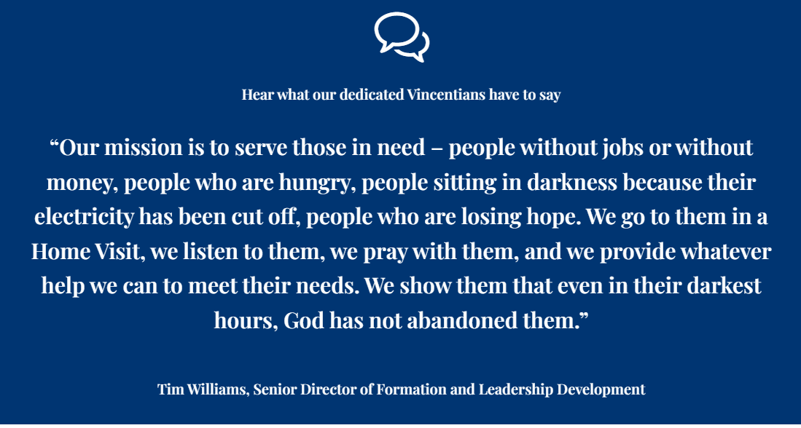
_________________________________________
Spread the word at Home Visits!
- Signs will be posted at both SVdP Stores. You can download and print a copy from our website.
